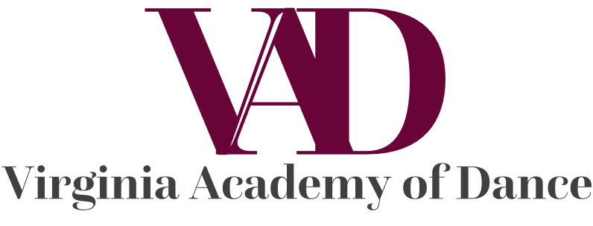

**Virginia Academy of Dance Registration**

Student Name _________________________________________  Birth Date___________

Parent or Guardian Name: _______________________________________________

Address:___________________________________________________________________

Phone: ____________________________  Parent/Guardian Cell Phone:________________

Email: __________________________________________________

Does this student have any allergies? ____________________________

Please describe: _____________________________________________

Does this student have any medical issues that instructor should be aware of? ____________

Please explain:______________________________________________________________

**Ballet Classes (Circle Your Choices) Session # ________________________**

Pre-Primary (3-4 years) 1x per week  $117 per Session

Primary- (5-6 years) Ballet & Tap Combination  1x per week $130 per Session

Level 1- (7 and up)  Ballet & Tap Combination 1x per week $130 per Session

Level 2- Ballet  1x per week $130 per Session

Level 3- Ballet/Pre-Pointe 2x per week $185 per Session

Debutants (13+ years)  Ballet/Pointe 1x per week $130 per Session

Level 4- (13+ years or with Instructor’s Permission)  Ballet/Pointe 2x per week $240 per Session

Level 5 and up (Placement Audition Required) Ballet/Pointe  2-3x per week $240-$300 per Session

**Elective Classes (Circle Your Choices) Each class 1x per week, $130 per Session *Levels 1-7 ONLY* Each Level is skill based, ask teacher for level placement**

Level A Options:    Tap      Jazz/Theatre   Modern Clogging

Level B Options:    Tap      Jazz/Theatre   Modern

Level C Options:    Tap      Jazz/Theatre   Modern

​

**Discounts are offered for multiple classes and sibling discounts.  
Additional discounts for payment in full at time of Registration.**

**Virginia Academy of Dance Liability Release Form**

While Virginia Academy of Dance makes every effort to use safe and healthy dance instruction, I understand that there are risks of physical injury associated with, arising out of and inherent to the activity of dance. In recognition of this acknowledged risk of injury, I knowingly and voluntarily waive all right and/ or causes of action of any kind, including any and all claims of negligence arising as a result of such activity from which liability could accrue to Virginia Academy of Dance, its officers, agents, employees, instructors, subsidiaries, parent corporations, and all affiliated entities (hereafter collectively referred to as Virginia Academy of Dance)

I hereby agree to release Virginia Academy of Dance and hold Virginia Academy of Dance harmless of all liability, and hereby acknowledge that I knowingly and voluntarily assume full responsibility for all risks of physical injury arising out of active participation in dance on behalf of the participant.

I understand that I will be held responsible in paying the full amount that is required of the classes and sessions my student may partake in. If my student does not finish the session that they are contracted in, whether by injury or personal inclination, I am aware that I still must pay the required amount.

I am aware that this is a release of liability and an acknowledgement of my voluntary and knowing assumption of the risk of injury. I have signed this document voluntarily and of my own free will in exchange for the privilege of participation.

I also give Virginia Academy of Dance permission to use my child’s picture and/or video in or on any form of advertisement for Virginia Academy of Dance or a VAD affiliated event. The participant has my permission to participate in Virginia Academy of Dance Events.

I warrant the below information is complete and correct. I further release Virginia Academy of Dance of all liabilities associated with my child’s attendance at Virginia Academy of Dance.

__________________________________________________ ___________ Parent/Guardian Signature, Date

______________________________________________________________   
Participant’s Name